Project Development Phase Model Performance Test

Date | 15 October 2026
Team ID | 23891A05C2
Project Name | Medical Diagnosis Center
Maximum Marks | 2 Marks

Model Performance Testing:
Project team shall fill the following information in model performance testing template.

S.No. | Parameter | Values | Screenshot
1. | Model Summary | The system uses ServiceNow to manage patient registration, diagnostic test booking, appointment scheduling, and report tracking. | 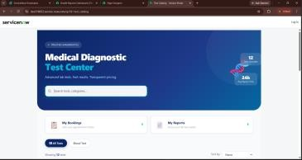
2. | Accuracy | Training Accuracy -Not Applicable ani rayi.  Validation Accuracy -Not  Applicable ani rayi. | Not Applicable
3. | Fine Tunning Result( if Done) | Validation Accuracy -Not Applicable – No ML model fine-  tuning performed. | Not Applicable

